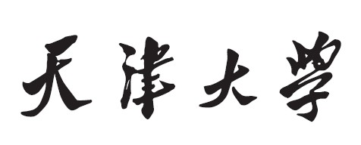

《计算机网络》



**题目：Wireshark Lab: TCP**

**学 院 智能与计算学部**__

**专 业 计算机科学与技术**

**年 级 2019_______**

**姓 名 张明君（留学生）**___

**学 号 6319000359______**

**2022年 4 月 20 日**

1. **Capturing a bulk TCP transfer from your computer to a remote server**

Before beginning our exploration of TCP, we’ll need to use Wireshark to obtain a packet trace of the TCP transfer of a file from your computer to a remote server. You’ll do so by accessing a Web page that will allow you to enter the name of a file stored on your computer (which contains the ASCII text of Alice in Wonderland), and then transfer the file to a Web server using the HTTP POST method (see section 2.2.3 in the text). We’re using the POST method rather than the GET method as we’d like to transfer a large amount of data from your computer to another computer. Of course, we’ll be running Wireshark during this time to obtain the trace of the TCP segments sent and received from your computer.

* Start up your web browser. Go the http://gaia.cs.umass.edu/wireshark-labs/alice.txt and retrieve an ASCII copy of Alice in Wonderland. Store this file somewhere on your computer.
* Next go to <http://gaia.cs.umass.edu/wireshark-labs/TCP-wireshark-file1.html>
* 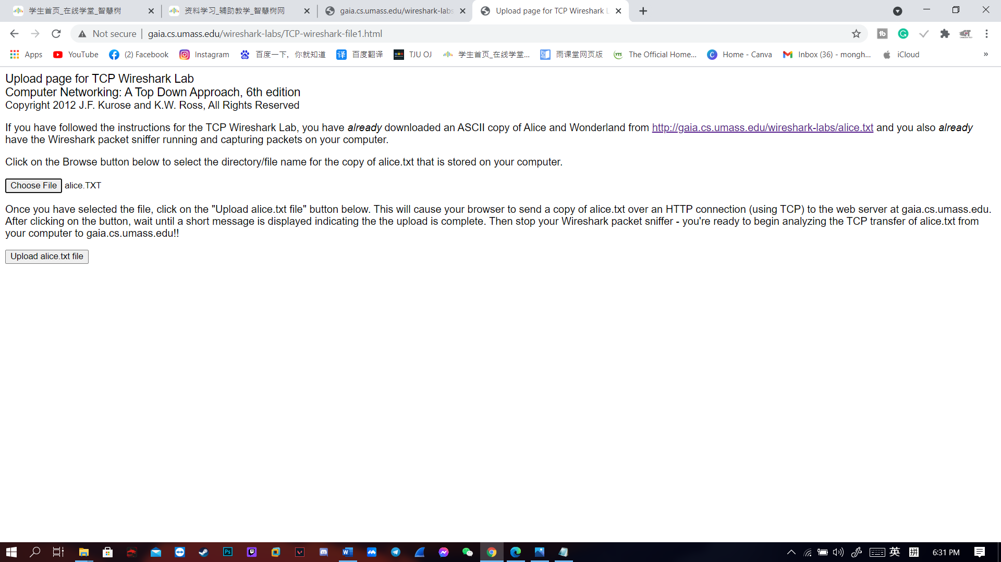You should see a screen that looks like
* Use the Browse button in this form to enter the name of the file (full path name) on your computer containing Alice in Wonderland (or do so manually). Don’t yet press the “Upload alice.txt file” button.
* Now start up Wireshark and begin packet capture (Capture->Start) and then press OK on the Wireshark Packet Capture Options screen (we’ll not need to select any options here)
* Returning to your browser, press the “Upload alice.txt file” button to upload the file to the gaia.cs.umass.edu server. Once the file has been uploaded, a short congratulations message will be displayed in your browser window.
* 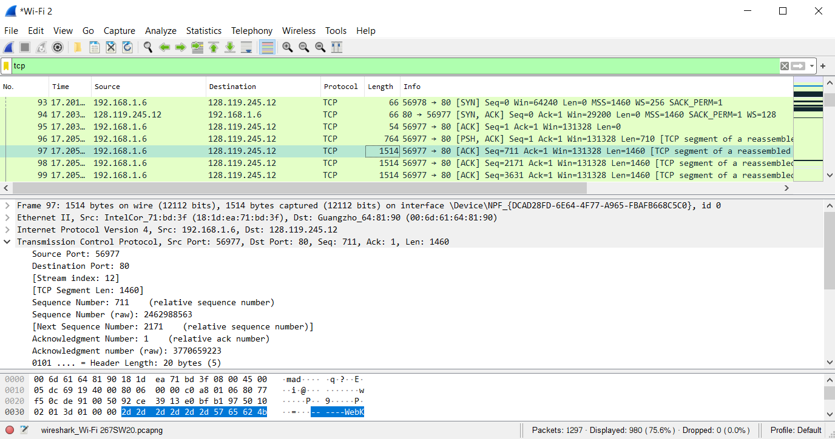Stop Wireshark packet capture. Your Wireshark window should look similar to the window shown below

Figure 1:Wireshark interface trace from browser

1. **A first look at the captured trace**

Answer the following questions, by opening the Wireshark captured packet file *tcp-ethereal-trace-1* in <http://gaia.cs.umass.edu/wireshark-labs/wireshark-traces.zip>.

1. What is the IP address and TCP port number used by the client computer (source) that is transferring the file to gaia.cs.umass.edu? To answer this question, it’s probably easiest to select an HTTP message and explore the details of the TCP packet used to carry this HTTP message, using the “details of the selected packet header window” (refer to Figure 2 in the “Getting Started with Wireshark” Lab if you’re uncertain about the Wireshark windows.

* **The IP address of the client computer is 192.168.1.102. The TCP port number is 1161.**

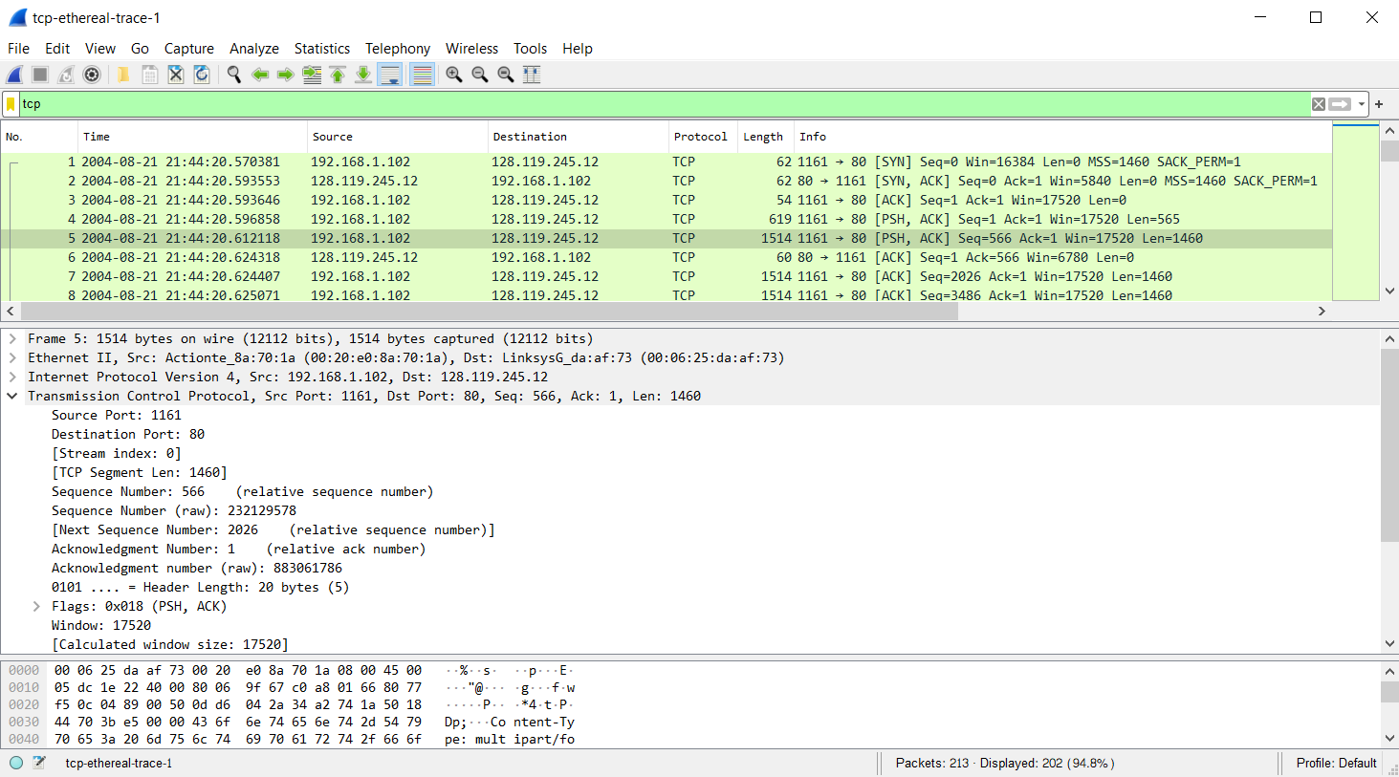

Figure 2:client IP and TCP port

1. What is the IP address of gaia.cs.umass.edu? On what port number is it sending and receiving TCP segments for this connection?

* **The IP address of gaia.cs.umass.edu is 128.119.245.12 and the TCP port is 80.**

Figure 3:Destination IP and TCP port

1. What is the IP address and TCP port number used by your client computer (source) to transfer the file to gaia.cs.umass.edu?

* **The IP address of client computer is 192.168.1.6 and TCP port is 56977.**

Figure 4: my own trace capture data

1. **TCP Basics**

Answer the following questions for the TCP segments:

1. What is the sequence number of the TCP SYN segment that is used to initiate the TCP connection between the client computer and gaia.cs.umass.edu? What is it in the segment that identifies the segment as a SYN segment?

* 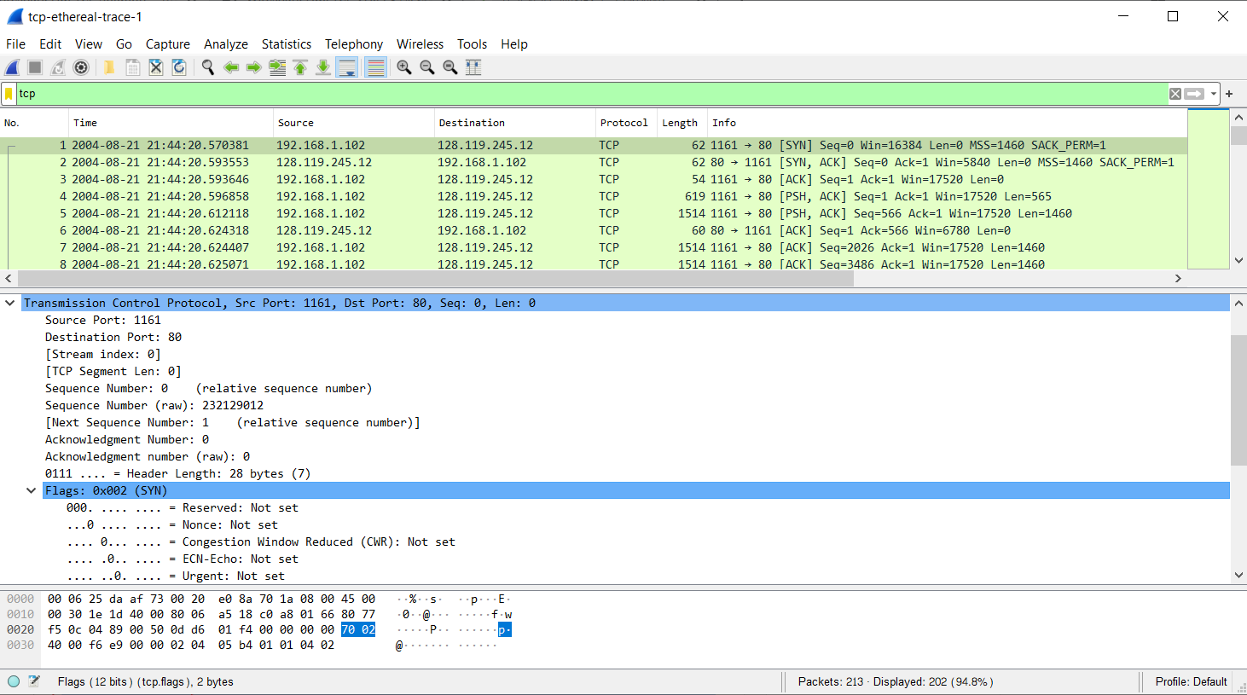**The sequence number of the TCP SYN segment is 0. Flags in the segment that identifies the segment as a SYN segment.**

Figure 5: TCP SYN segment

1. What is the sequence number of the SYNACK segment sent by gaia.cs.umass.edu to the client computer in reply to the SYN? What is the value of the Acknowledgement field in the SYNACK segment? How did gaia.cs.umass.edu determine that value? What is it in the segment that identifies the segment as a SYNACK segment?

* 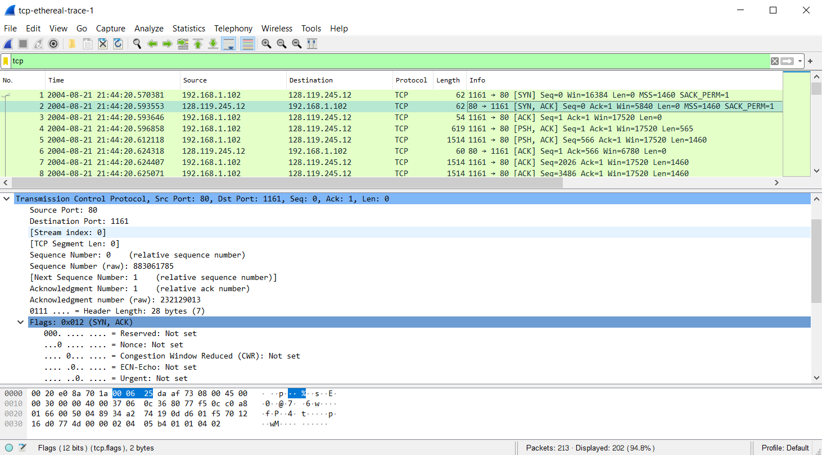**The sequence number of the SYNACK segment is 0. The value of the Acknowledgement field in the SYNACK segment is 1. Flags identifies the segment as a SYNACK segment.**

Figure 6:SYNACK segment value

1. What is the sequence number of the TCP segment containing the HTTP POST command? Note that in order to find the POST command, you’ll need to dig into the packet content field at the bottom of the Wireshark window, looking for a segment with a “POST” within its DATA field.

* **The sequence number of the TCP segment containing the HTTP POST command is 1.**

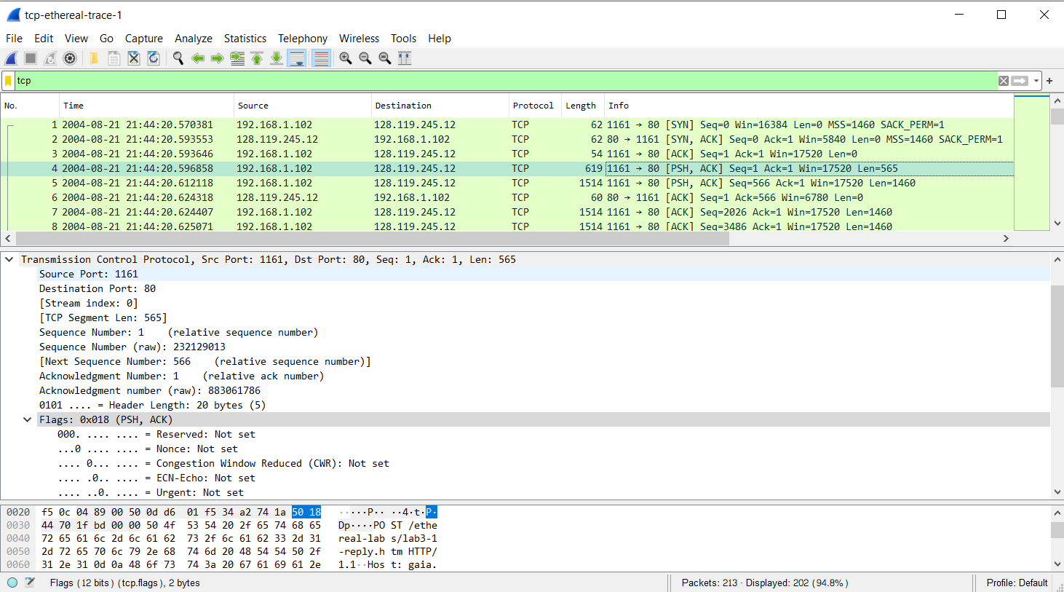

Figure 7:TCP segment containing HTTP POST

1. Consider the TCP segment containing the HTTP POST as the first segment in the TCP connection. What are the sequence numbers of the first six segments in the TCP connection (including the segment containing the HTTP POST)? At what time was each segment sent? When was the ACK for each segment received? Given the difference between when each TCP segment was sent, and when its acknowledgement was received, what is the RTT value for each of the six segments? What is the EstimatedRTT value (see Section 3.5.3, page 239 in text) after the receipt of each ACK? Assume that the value of the EstimatedRTT is equal to the measured RTT for the first segment, and then is computed using the EstimatedRTT equation on page 239 for all subsequent segments.

* **Below I will do the table for the first six TCP segment in the TCP connection and packet number also the sequence number and Time sent and Time ACK received and the last one is RTT. So now we have to look at the screenshot below that we captured in Wireshark.**

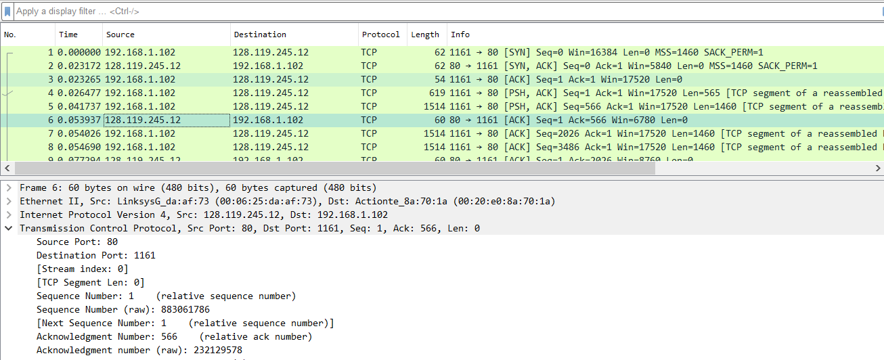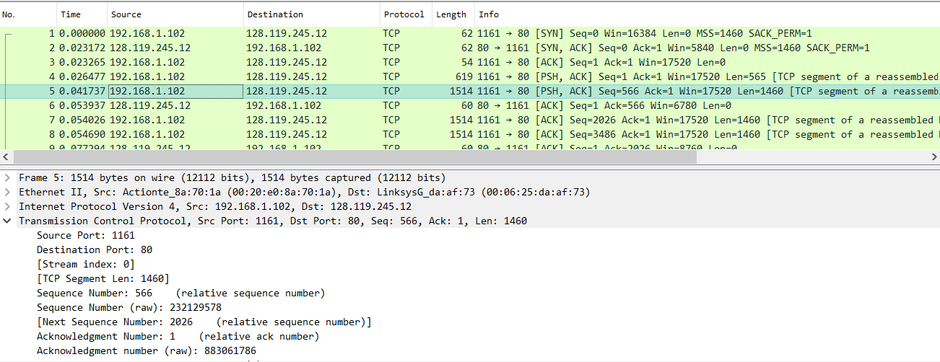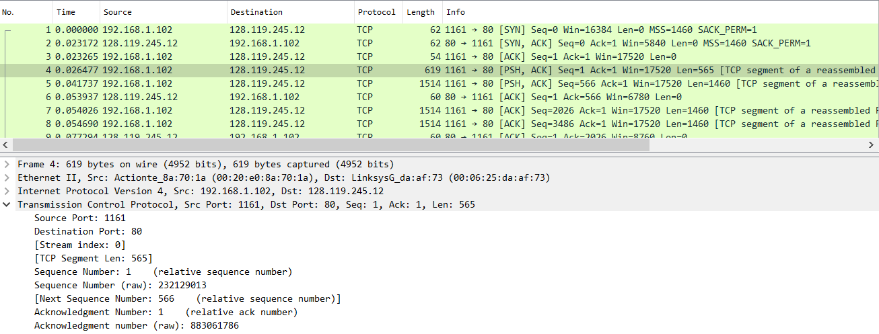

Figure 10: Second ACK received

Figure 9: Second sequence number and First ACK received

Figure 8: First sequence number

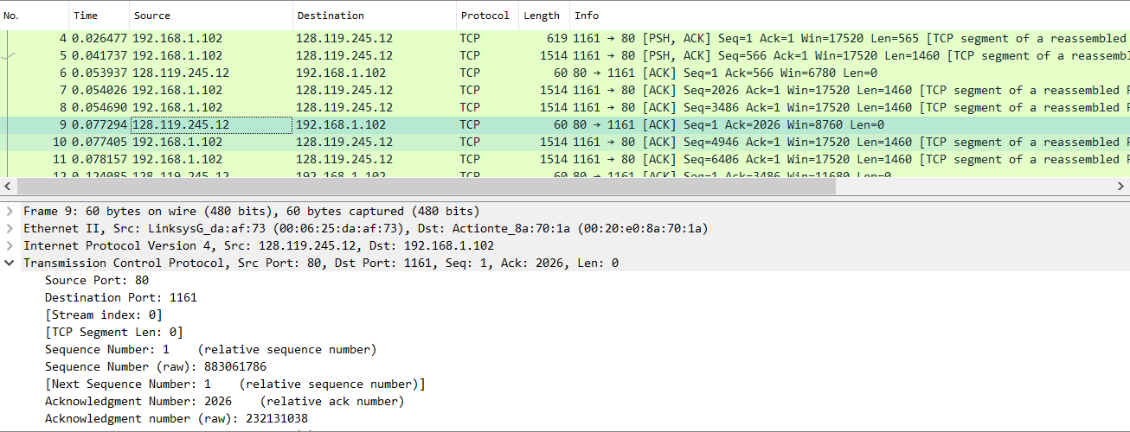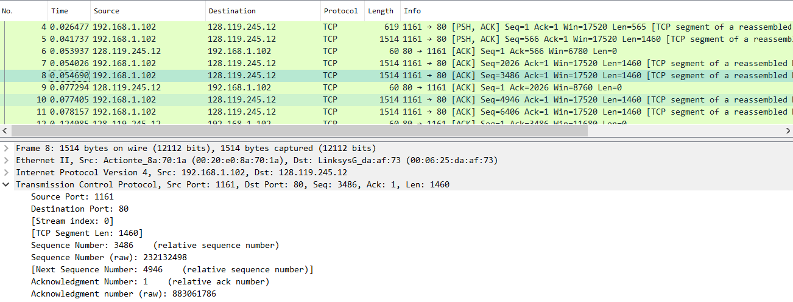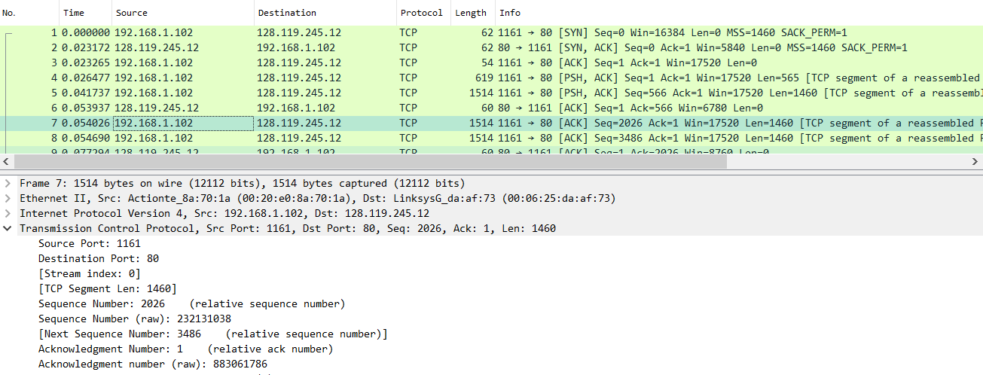

Figure 13: Third ACK received

Figure 12: Fourth sequence number

Figure 8: Third sequence number

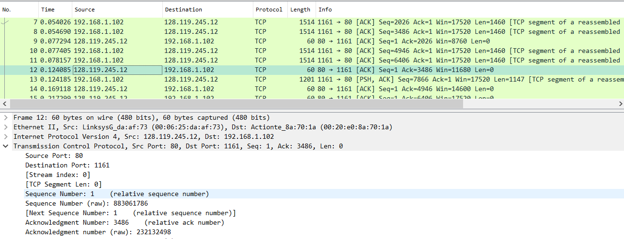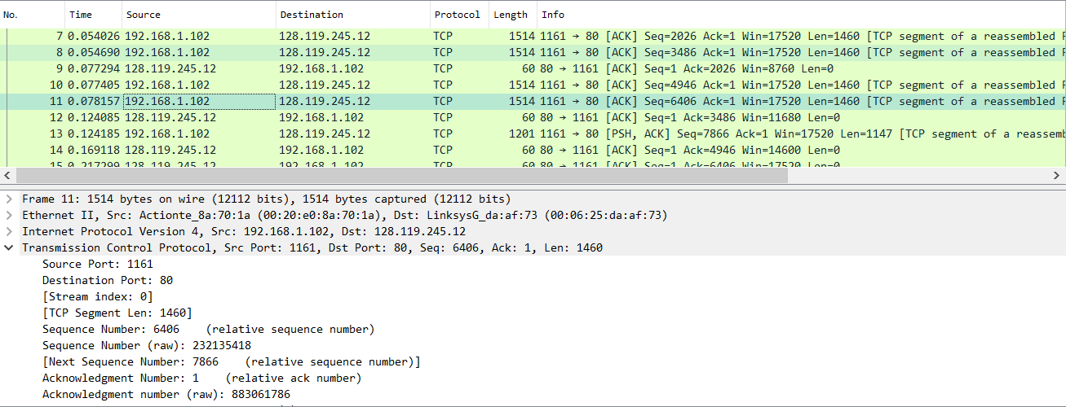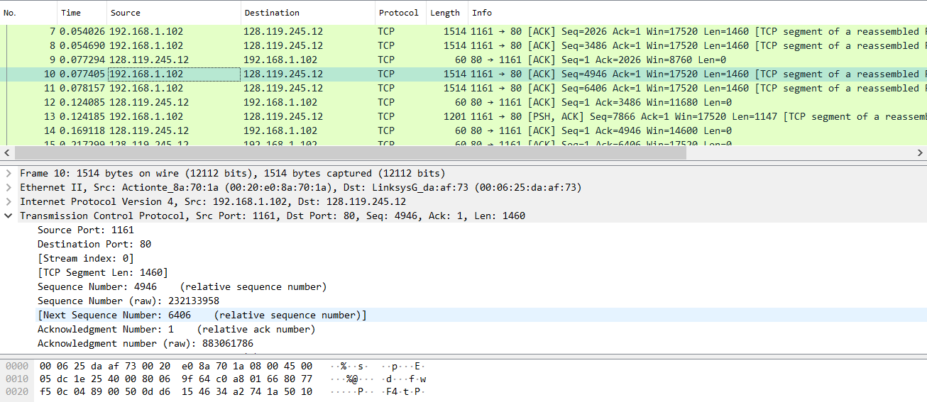

Figure 16: Fourth ACK received

Figure 15: Sixth sequence number

Figure 9: Fifth sequence number

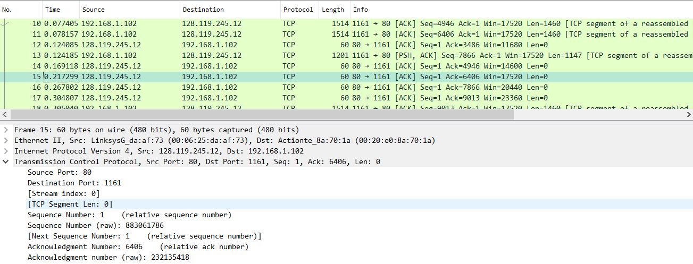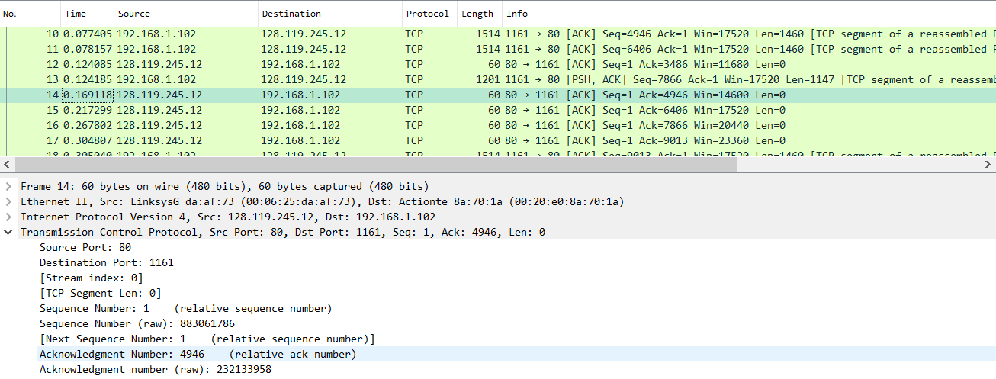Here is the table that described about the sequence number and Time sent also Time ACK received and last one is RTT:

Figure 18: Sixth ACK received

Figure 17: Fifth ACK received

|  |  |  |  |  |  |
| --- | --- | --- | --- | --- | --- |
| **Segment** | **Packet Number** | **Sequence Number** | **Time Sent(s)** | **Time ACK received(s)** | **RTT(s)** |
| 1 | 4 | 1 | 0.026477 | 0.041737 | 0.01526 |
| 2 | 5 | 566 | 0.041737 | 0.053937 | 0.0122 |
| 3 | 7 | 2026 | 0.054026 | 0.077294 | 0.023268 |
| 4 | 8 | 3486 | 0.054690 | 0.124085 | 0.069395 |
| 5 | 10 | 4946 | 0.077405 | 0.169118 | 0.091713 |
| 6 | 11 | 6406 | 0.078157 | 0.217299 | 0.139142 |

1. What is the length of each of the first six TCP segments?

* 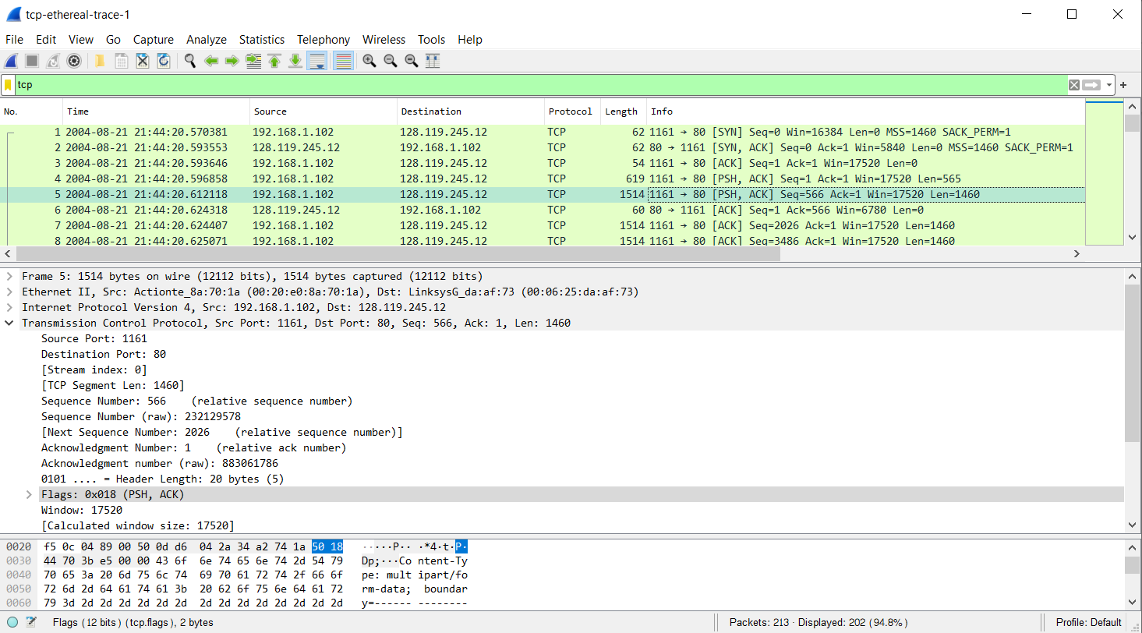**The length of the first segment is 565, others from 2 to 6 are 1460.**

Figure 20: Second length of TCP segment

Figure 19: The length of the first TCP segment

**Because of the length from second TCP segment to sixth TCP segment are the same so I only use one screenshot to describe it.**

1. What is the minimum amount of available buffer space advertised at the received for the entire trace? Does the lack of receiver buffer space ever throttle the sender?

* 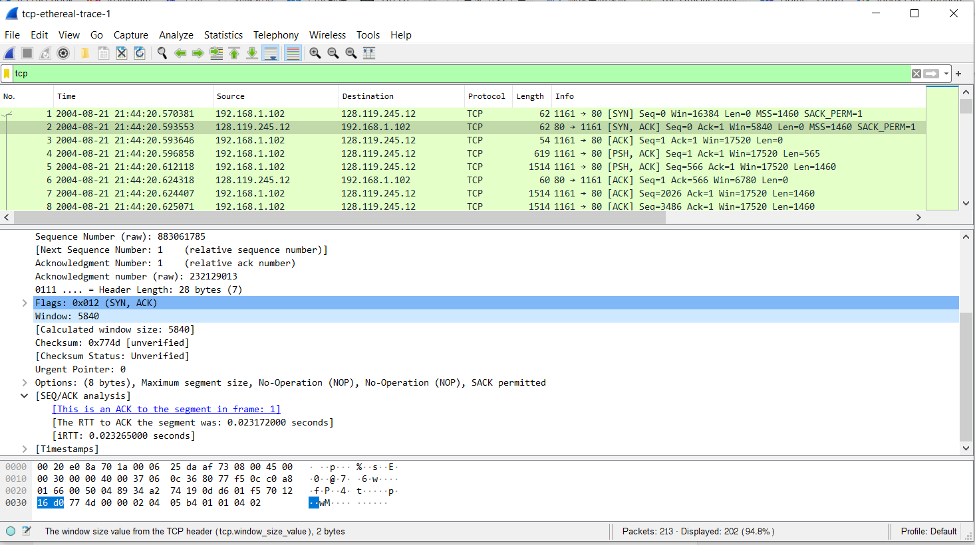**5840.No throttle is made due to the lack of buffer space.**

Figure 21: The minimum available buffer space

1. . Are there any retransmitted segments in the trace file? What did you check for (in the trace) in order to answer this question?

* 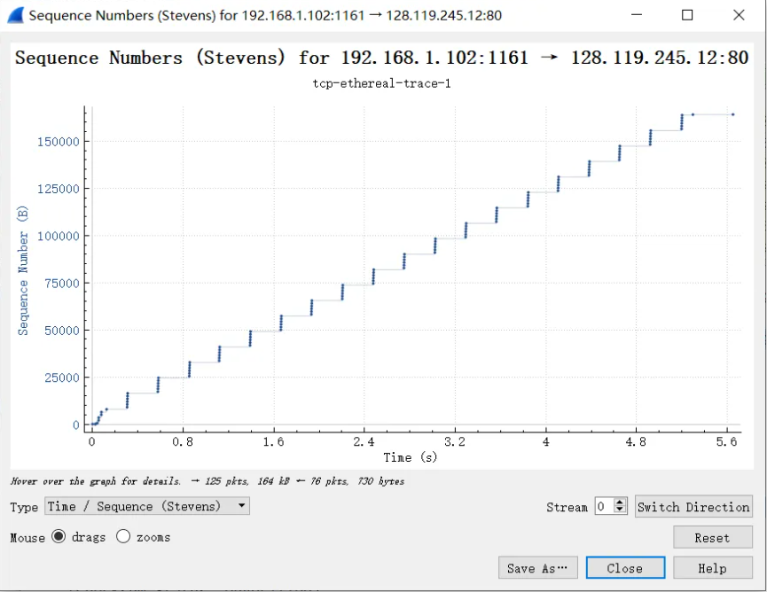**There is no retransmitted segment in the trace file.**

Figure 22: Sequence number graph

1. How much data does the receiver typically acknowledge in an ACK? Can you identify cases where the receiver is ACKing every other received segment (see Table 3.2 on page 247 in the text).

* 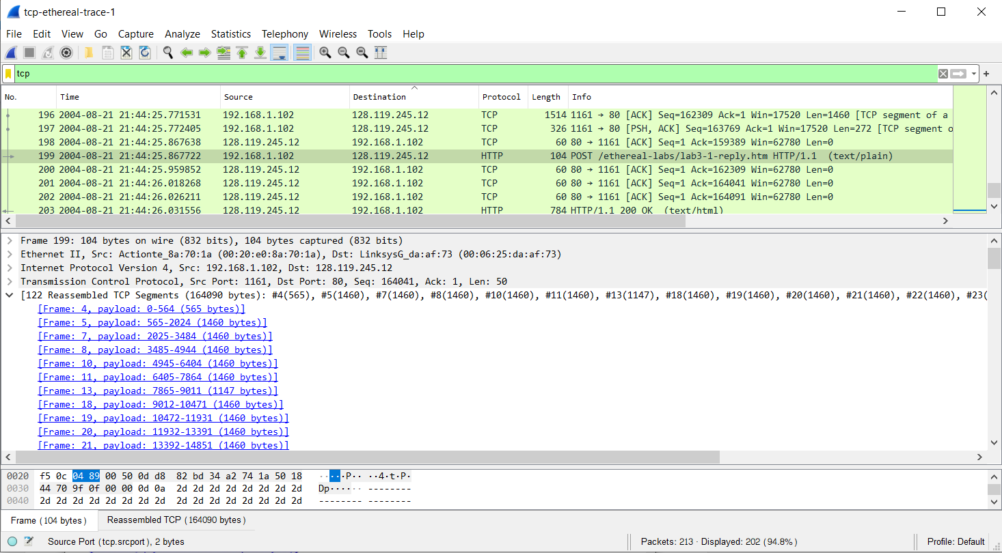**164090 bytes. According to the screenshot below, we can see that the ACK numbers increase in the sequence of 565,1460,1460 and so on.**

Figure 23: Data of receiver in ACK

1. What is the throughput (bytes transferred per unit time) for the TCP connection? Explain how you calculated this value.

* **To calculate the value we have the formula below:**

*Amount of data transmitted=164090 bytes*

*Time incurred=5.297341 s*

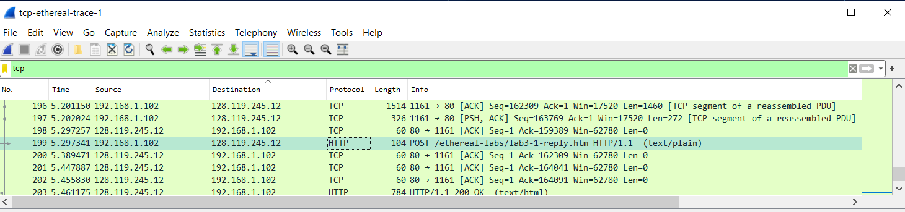 *=30.9759 kbytes/s*

Figure 24: Time incurred

1. **TCP congestion control in action**

Let’s now examine the amount of data sent per unit time from the client to the server. Rather than (tediously!) calculating this from the raw data in the Wireshark window, we’ll use one of Wireshark’s TCP graphing utilities - Time-Sequence-Graph (Stevens) - to plot out data.

* Select a TCP segment in the Wireshark’s “listing of captured-packets” window. Then select the menu : Statistics->TCP Stream Graph-> Time-Sequence-Graph(Stevens). You should see a plot that looks similar to the following plot, which was created from the captured packets in the packet trace *tcp-ethereal-trace-1* in http://gaia.cs.umass.edu/wireshark-labs/wireshark-traces.zip (see earlier footnote ):

Answer the following questions for the TCP segments the packet trace *tcp-ethereal-trace- 1* in http://gaia.cs.umass.edu/wireshark-labs/wireshark-traces.zip

1. Use the Time-Sequence-Graph(Stevens) plotting tool to view the sequence number versus time plot of segments being sent from the client to the gaia.cs.umass.edu server. Can you identify where TCP’s slow start phase begins and ends, and where congestion avoidance takes over? Comment on ways in which the measured data differs from the idealized behavior of TCP that we’ve studied in the text.

* **By observing the plot, we can see that the slow-start phase only lasts for first 0.8-1.6 second. Afterwards, it seems that the TCP session is always in congestion avoidance state. In this case, we do not observe the expected linear increase behavior, i.e. the TCP transmit window does not grow linearly during this phase. In fact, it appears that the sender transmits packets in batches of 6. This does not seem to be caused by flow control since the receiver advertised window is significantly larger than 5 packets. The reason for this behavior might be due to the fact that the HTTP server has enforced a rate-limit of some sort.**

1. Answer each of two questions above for the trace that you have gathered when you transferred a file from your computer to gaia.cs.umass.edu

Figure 25: Sequence number graph

* **I already answered it above so my job is done now.**